**Hibah Helper**

**Output :**

1. Persuratan mengenai hibah
2. Ijin Prinsip Hibah
3. Persetujuan Hibah
4. Usulan Hibah
5. Reporting
6. Progress pelaksanaan hibah (by Satker, Jenis BMN, Direktorat, Provinsi, etc)
7. Monitoring status hibah (status pelaksanaan apakah di CK, Biro, Sekjen, Kemenkeu, atau Setneg)
8. Evaluation

**Users :**

1. Superadmin
2. User
3. Viewer

**Workflow**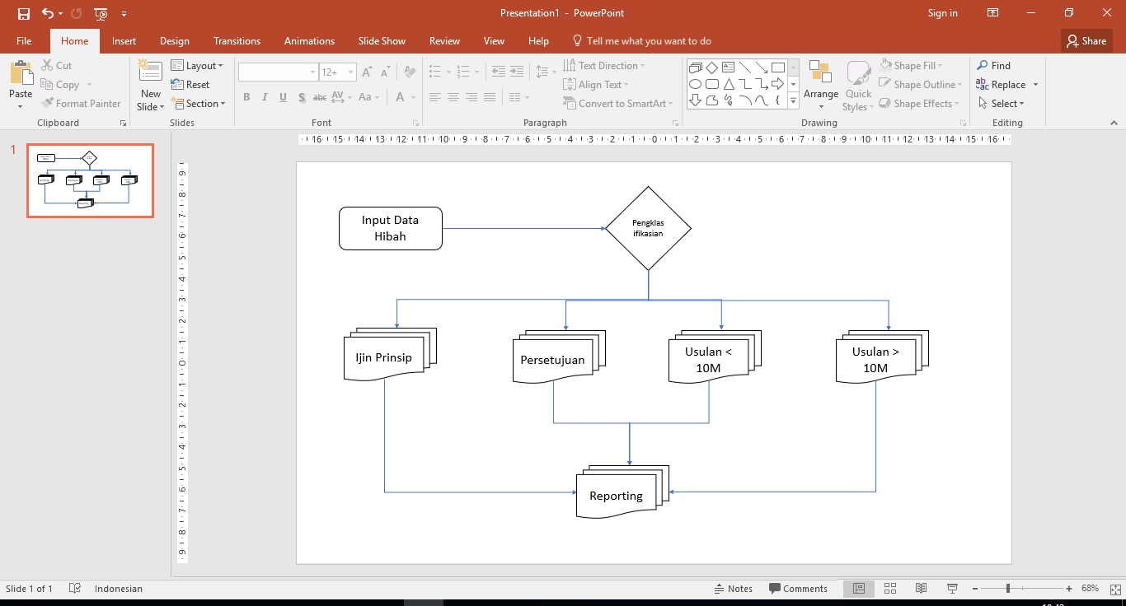

**Data :**

[Data BMN](MONEV%20HIBAH%20CK%202017%20updated.xls)

[Format Ijin Prinsip KPKNL](IJIN%20PRINSIP%20pspam%20gorontalo%20dc-905.1%20-%20kpknl.xls)

[Format Ijin Prinsip Kanwil](IJIN%20PRINSIP%20bangkim%20bengkulu%20dc-971%20-%20KANWIL.xls)

[Format Persetujuan](PMK4_KALUTARA_5.133.942.000.xls)

[Format Usulan < 10 M](Konsep%20Permohonan%20Hibah%20PSPAM%20gorontalo%20dc-905%20V.xls)

[Format Usulan > 10 M](Konsep%20Permohonan%20Hibah%20PSPAM%20gorontalo%20dc-905%20djkn%20II.xls)

**Contoh UI :**

1. **Input Data BMN**
2. **Reporting**